hive query to find the city wise list all the Condos which is not less than ten thousand

select distinct city from realestate where type=’Condo’ price>10000;

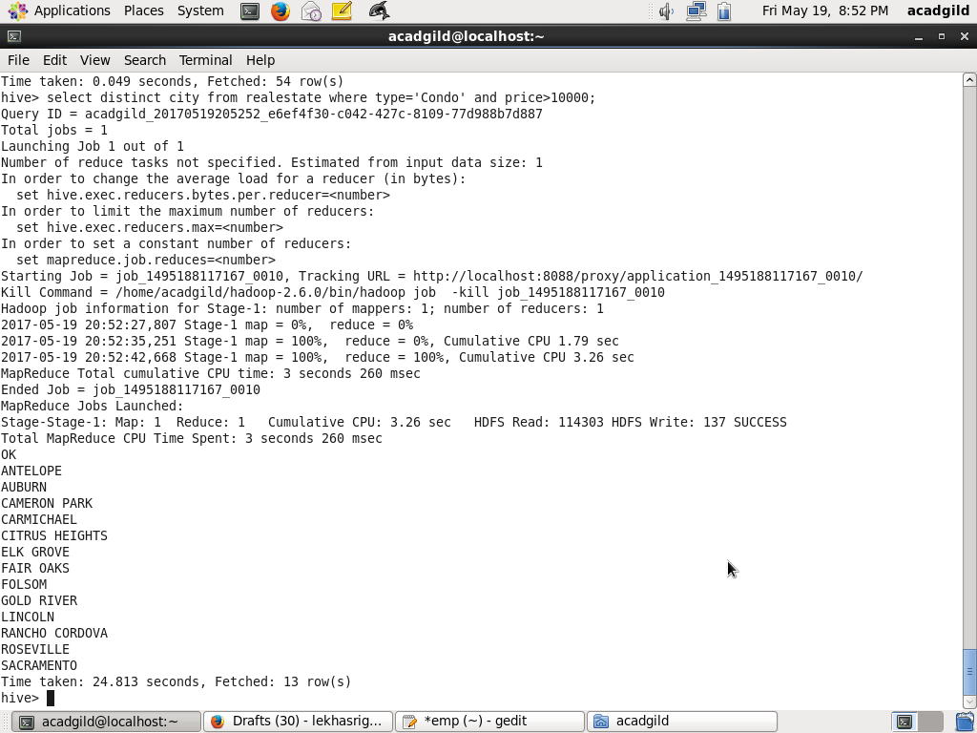

hive query to find which is the cheapest Condo in CA. name the city,street and price for the Condo.

select city,street,price from realestate order by price limit 1;

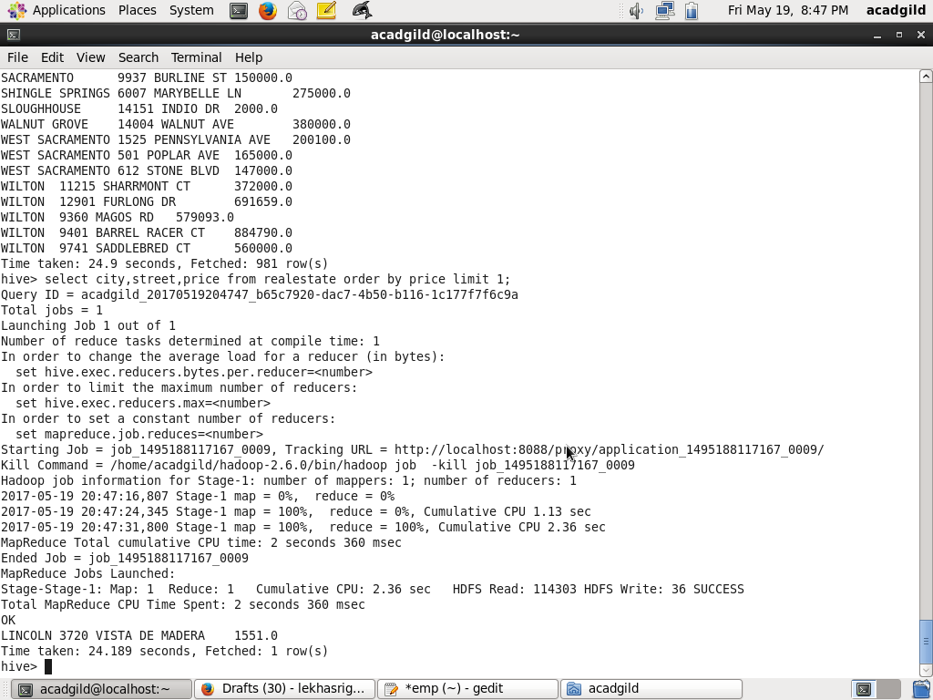

hive query to list top 5 residency details which lie in the budget

of 60000-120000, an area more than 1450, sold after 17th may, min bedroom 3 and,min bathroom 2.

select * from realestate where sq_ft>1450 and price>60000 and price<120000 and beds>=3 and baths>=2  order by sq_ft,price,beds,baths limit 5;

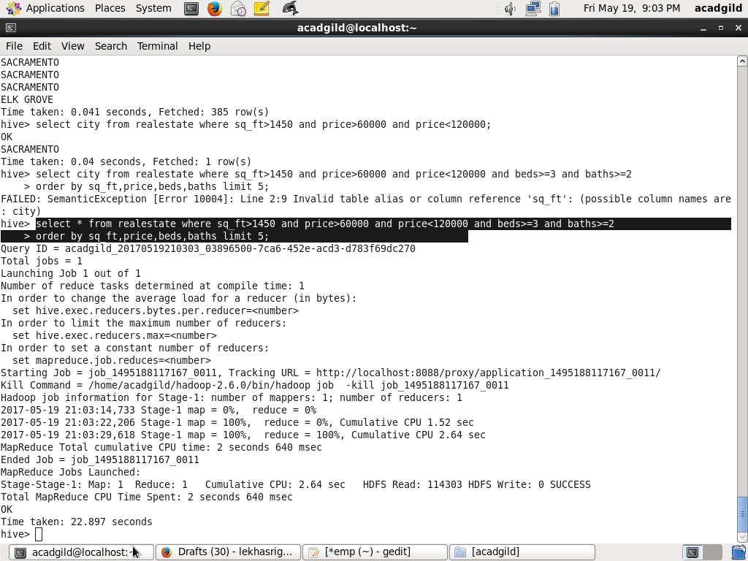

hive query to separate list of residential apartments with more than 2 beds. Also include

columns in following order City,Baths,Sq_feet,Price,flat_type,Beds respectively.

select city,baths,sq_ft,price,type,beds from realestate where beds>2 and type='Residential';



